The **Xrm.Page.data.process** namespace provides events, methods, and objects to interact with the business process flow data in a form.

See [Xrm.Page.ui.process (client-side reference)](https://msdn.microsoft.com/en-us/library/dn817860.aspx) for methods to interact with the business process flow control in the form.

A business process flow lets you create more efficient and streamlined sales, service, and other business processes. Having high performing processes in place will help you to increase your win rates, improve customer satisfaction, and grow your revenue.

A business process flow creates a visualization of your business process by placing special controls at the top of the entity forms. Users are guided through various stages of sales, marketing, or service processes towards completion. Each process supports multiple stages and steps. You can add or remove steps, change the order of stages, or add new entities to the business process flow.

You can only run one business process per record.  This means you can switch business process flows if you security role allows but you do this by quitting the current business process flow.

You can stop a user from moving on a stage by making a field required

Stats – each entity can have 10 business process flows! A business process flow can have 30 stages.

All fields on an entity can be used in a business process flow, even fields which are not held on the form.

CRM Process Flows guide users through each step in a defined process to clearly see what steps have been completed, and what needs to happen next. - See more at: http://www.preact.co.uk/blog/enhanced-business-process-flows-in-microsoft-dynamics-crm-2015#sthash.9K4rnnU3.dpuf

However, in CRM 2013 Business Process Flows were subject to several limitations.

Firstly, they didn't support branch logic (If / Else) and were only designed to work in a linear manner.

- See more at: http://www.preact.co.uk/blog/enhanced-business-process-flows-in-microsoft-dynamics-crm-2015#sthash.9K4rnnU3.dpuf

Another restriction in CRM 2013 only enabled entities to be added to the process flow if a one : many relationship existed. CRM 2015 will add entities to your BPF even if they don’t have a relationship to the entity you’re coming from. - See more at: http://www.preact.co.uk/blog/enhanced-business-process-flows-in-microsoft-dynamics-crm-2015#sthash.9K4rnnU3.dpuf

<http://www.preact.co.uk/blog/enhanced-business-process-flows-in-microsoft-dynamics-crm-2015>

All fields on an entity can be used in a business process flow, even fields which are not held on the form.

Field level security is applied to the fields in the business process control but if a field is required to be filled in but the user doesn’t have the correct field level security permissions, the business process flow will act as if it has a value.  This ensures users cannot get stuck in a business process flow due to lack of field level security privileges.

• only deactivated business process flows can be edited.

• Business process flows have stages, each stage can have many steps

• Different entities used must have a N: 1 relationship to the previous entity

• When a field is updated in the business process flow it will trigger related business rules and JavaScript

• Field level security is applied to fields in the process control

Business process flows are linear, there is no branching or logic

Stage gating is making field required before a user can move to the next stage

Business processes do not have any conditional or branching logic. They run in a linear, staged process.

You can only run one business flow for each record

**Role-based Processes:**

Just like we can design role based forms in CRM, the Business Process flows also provide the option of designing different processes for different kinds of users. You can assign roles to the Processes using the Enable Security Roles option

[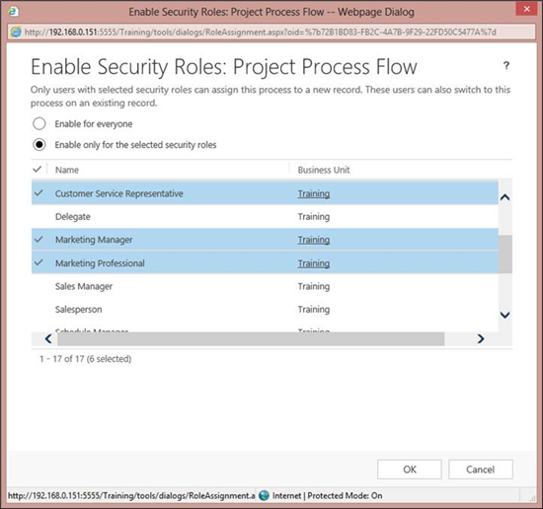](https://community.dynamics.com/cfs-file.ashx/__key/communityserver-blogs-components-weblogfiles/00-00-00-02-35/0243.7.png)

**Maximum number of processes, stages, and steps**

Per entity, the default value for the maximum number of activated business process flows is 10. You can specify a different value by using the **Organization.MaximumActiveBusinessProcessFlowsAllowedPerEntity** attribute. However, if the value is greater than 10, you may see a decrease in your system’s performance when you switch processes or open a record that has an assigned business process flow. This may be especially noticeable if processes span multiple entities.

The following settings aren’t customizable:

* The maximum number of stages per entity in the process is 30.
* The maximum number of steps in each stage is 30.
* The maximum number of entities that can participate in the process flow is 5.

**Use client-side script to automate interaction with business process flows**

|  |  |  |  |
| --- | --- | --- | --- |
| Entity enabled for business process flow | **ProcessId** | The ID of the business process flow in which the entity record participates. | GUID |
| Entity enabled for business process flow | **StageId** | The ID of the stage in the business process flow to which the entity record is assigned. The stage consists of logically connected steps. The stages and steps are described in the **Workflow.XAML** attribute. | GUID |